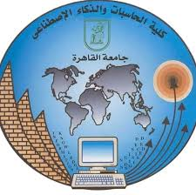2

**Web technology project-Phase 2**

**Project 2 (Student Affairs website)**

**S3**

|  |  |
| --- | --- |
| Name | ID |
| Fouad Sayed Fouad | **20200384** |
| Mohammed Samy Abdelsalam | **20200445** |
| Mohamed Sayed khalil | **20200449** |
| Hesham Ahmed Mohamed | **20201211** |
| Hassan Tamer Ali | **20200152** |
| Ziad adel sayed | **20200760** |